**9-11-23 notes**

Orientation

Courtney Totty- Student Engagement Specialist- [CTotty@bootcampspot.com](mailto:CTotty@bootcampspot.com)

Requirements for getting certificate:

Do NOT miss more than 4 classes

Complete all 3 projects

Miss or Late on only 2 homework assignments or less

* Can resubmit assignments after due date
  + Zero on an assignment
  + Get a higher grade
* More in depth feedback available from instructor and TAs

Class recordings available on BootCampSpot via course, Zoom, Previous meetings tab

* Usually available 24-48 hours after class ends

Within 1 week (By 6:30pm Monday 9/18) you can drop class for any costs aside from $1k deposit

Weekly surveys required via BCS

Code of conduct: Don’t be a jerk, don’t market

BootCampSpot (BCS):

* **USE CAREER SERVICES**
* Request tutoring via Student support option on left
  + 24 hours (total bucket) of Tutoring available (roughly 1 hour per week)
  + https://tinyurl.com/BootCampTutorTeam
* Grades (avg 1-week turnaround after submitting)
  + Central grading grades weekly homework
  + Instructor and TAs grade Projects

Slack Channels:

#01-Live- For questions during class

#02-Ask-The-Class- Field questions to fellow students in the cohort

Day 1- Zen of Data

Manish Jariwala- Instructor

Data is ineffective without leveraging it via

* Actionable insights
* Predictions

Data science: Use of Statistics, programming, and analytics to extract meaning from data

* It’s about storytelling and truth-telling

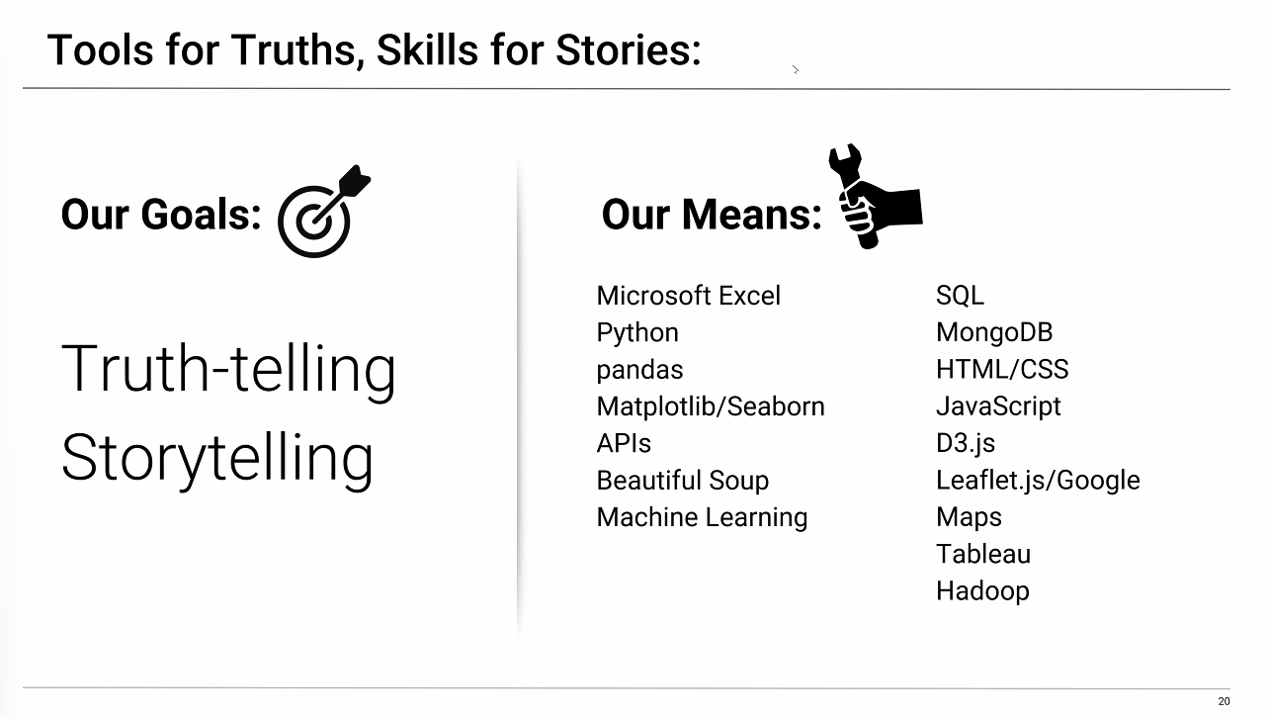

R can also be used as a tool (similar to Pandas Library), though Python is more mainstream

We’ll also go over basic statistics (IE: Linear regressions)

Each class includes:

* Overview of topics
* Instructor Lecture
* Instructor Demo
* Class Discussion
* In-Class Activities
* Project work

Excel has integrated Pandas and Python (in Beta)

Will cover VB script coding and fundamentals of coding in week 1 and wk2.

Unique focuses for group projects- Manufacturing/industrial, meteorology, sports, finance, healthcare, etc.

We are getting EXPOSED to a whole bunch of applications, no need to freak out over not being an expert by the end of the module.

Helpful tips-

Embrace your inner toddler- embrace curiosity

Brace yourself for Doubts, Challenges, and Confusion

Form a community with your classmates

Enjoy the novice experience

Expect a lot of Lightbulb Moments at first (few and far between later on in professional career)

Celebrate your successes

My favorites: I want to enjoy and excel at Excel, Python, and Tableau

Example:

Do Americans prefer Italian or Mexican food?

How To (Use Analytics Paradigm):

Decompose the Ask:

* Define Americans
* Get a representative sample
  + IE: College students in X-grade, yelp reviews of top 5 Italian vs top 5 Mexican restaurants in 10 cities, 100+ zip codes, Et Cetera…
* Define preference
  + Do people prefer the foods they eat most frequently?
  + Do people prefer the foods they wish they could eat if cost wasn’t an issue?
  + ***Conclusion: Preference is subjective. We need objective data.***

ID Data Sources:

* Data sets online already
* Have your team poll people on the road
* Online survey

Define strategy and metrics:

* Categorize data
* Organize it
* Visualize it

Build Data Retrieval plan

* Don’t pull it manually if you can help it.
  + (Manually pulling is called Brute forcing it)
  + It’s time consuming
* Use API to pull the data #ThankGoodnessForProgramming
* Save output to data frame (ie: Pandas)

Assemble and clean the data

* Aggregate and merge data as needed

Analyze for trends

* Average rating
* Total number of review (Review counts)
* P-Value (t-test)

Acknowledge limitations of the analysis

* Yelp reviewers may not be an accurate representation of the American people.

Make the call:

* What is the “Proper” conclusion (present it to the upper management or executive level)

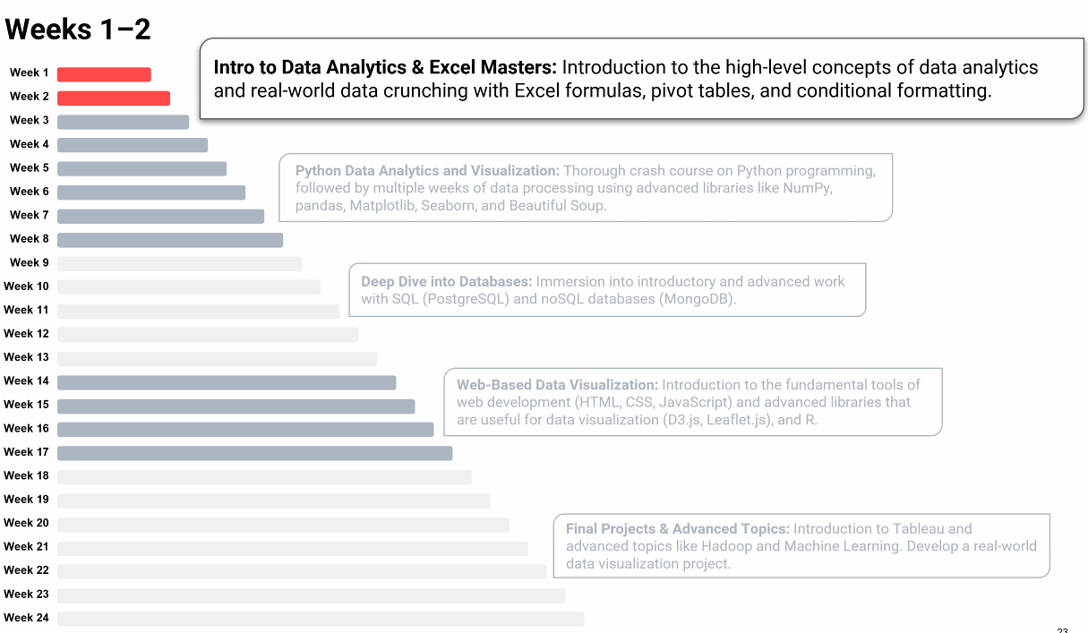

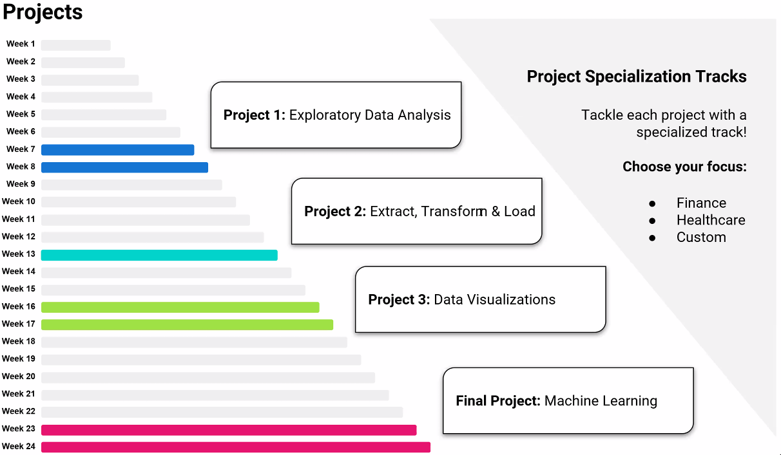

How To:

